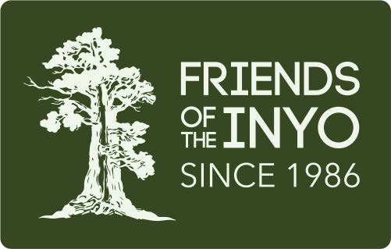

January 14, 2019

The Honorable Pete Aguilar
109 Cannon House Office Building
Washington, DC 20515

Dear Congressman:

The Alabama Hills Stewardship Group and Friends of the Inyo wishes to extend our sincere thanks for co-sponsoring the California Desert Protection and Recreation Act (CDPRA) in the 116th Congress, and commend you for your support of conservation in the California Desert.

This bill will guarantee both appropriate conservation measures and continued access to this incredibly scenic landscape. Outdoor recreation is the heart of our local rural economy. This designation will help allow for better-funded maintenance and management of this area, which is undergoing increased use and resource damage. The provisions of the bill will help boost the significant outdoor recreation economy in the California Desert, and uphold the priorities of the public throughout the desert.

With the New Year and a new Congress we offer any help we may be able to provide in bringing HR.376 to the floor for a vote. Please know we are here to assist in whatever way needed to see passage of this important piece of long overdue legislation.

Sincerely,

/s/ Jora Fogg
Policy Director
Friends of the Inyo

/s/ Kevin Mazzu
Alabama Hills Stewardship Group

